CANSAT 2022-23

Critical Design Review

(CDR)

**TEAM ID: 2022ASI-002**

**TEAM NAME: ASTROPEEP**

|  |  |
| --- | --- |
| Serial N0. | CONTENTS |
|  | Team description |
|  | Sponsorship to CANSAT |
|  | List of Acronyms |
|  | System Overview |
|  | Sensor Summary |
|  | Mechanical Material Selection & Overview |
|  | Mechanical Subsystem Analysis & Results |
|  | Power Budget |
|  | Mass Budget |
|  | Actuator Design |
|  | Control Mechanism of Gyroscope |
|  | Trajectory & Descent Control |
|  | Sensor Testing |
|  | Communication & Data Handling |
|  | Electrical Power Subsystem |
|  | Flight Software Design |
|  | GCS Deign & Over View |
|  | CANSAT Algorithm |
|  | Ground Station Final test Results |
|  | CANSAT Ready to launch & Final test result |
|  | CANSAT Integration & Testing |
|  | Mission Operation and analysis |
|  | Pre-flight requirement-check analysis |
|  | Logistics and Transportation |
|  | CANSAT ready to launch and final comments |
|  | Conclusion |

***Team Description***

***Sponsorship to CANSAT***

We as Team Astropeep have received the sponsorship from different organisation and institutions, in form of money and in the form of goods.

List of sponsors are as mentioned below:

1. Institute of Infrastructure Technology Research and Management, Ahmedabad
2. Centre of Advanced Defence Technologies, IITRAM, Ahmedabad
3. Indian Studytech Services Pvt. Ltd., Dholpur, Rajasthan
4. Rudrabots Pvt. Ltd., Ahmedabad

***List of Acronyms***

|  |  |
| --- | --- |
| Acronyms | Meaning |
| 3D | 3-Dimensional |
| A | Analysis |
| cm | Centimeter |
| D | Demonstration |
| dB | Decibel |
| EPS | Electrical power Subsystem |
| FRR | Flight Readiness Review |
| FSW | Flight Software |
| GCS | Ground Control System |
| gm | Gram |
| GPS | Global Positioning System |
| GS | Ground Station |
| GUI | Graphical User Interface |
| Hz | Hertz |
| I | Inspection |
| I2C | Inter-Integrated Circuit |
| IC | Integrated Circuits |
| LED | Light Emitting Diode |
| PC | Personal Computer |
| QHA | Quasi Harmonic Function |
| RTC | Real Time Clock |
| T | Test |
| VM | Verification Method |
| GHz | Giga Hertz |
| s | Second |
| csv | Comma separated values |
| hrs | Hours |
| PCB | Printed Circuit Board |
| mAh | Milli ampere hour |
| m | Meter |
| V | Volts |
| FSS | Flight Software State |

System Overview

MISSION SUMMARY

* Innovative Mechanical Gyro-control system that shall demonstrate the descent control of the CANSAT.
* CANSAT descent control system that shall open at an altitude of 500 m.

CANSATs will be launched to an altitude of 800.0 m to 900.0 m from the ground level and above the launch site & deployed near the peak altitude. During the ejection from the rocket orientation of the CANSAT is not controlled. The CANSAT must remain intact during the course of the entire mission and send the data to the ground station through a telemetry link.

|  |  |  |  |  |  |  |  |
| --- | --- | --- | --- | --- | --- | --- | --- |
| Sr.no. | Requirement | Priority | Fulfillment | VM | | | |
| A | I | T | D |
| 1 | Total mass of the CANSAT shall be under 0.700 kg (+/- 0.050 kg) | High | Mass of Cansat is within limits. | x |  |  | X |
| 2 | CANSAT shall fit in a cylindrical body of 0.125 m diameter x 0.310 m height.  Tolerances are to be included to facilitate container deployment from the rocket fairing. | High | Cansat is designed with appropriate dimensions. | X |  |  | X |
| 3 | Any sharp edges on the container body shall be avoided as it can cause interfere during the CANSAT ejection from the rocket. | High | No sharp Edges are present. | X |  |  | X |
| 4 | Color of the CANSAT body shall be fluorescent i.e., pink, red or orange, and shall embody the Indian flag. | High | Color will be fluorescent and will embody Indian Flag. |  |  |  | X |
| 5 | The CANSAT shall consist of necessary sensors to provide the following mandatory Real-time datasets: Position data, altitude, pressure, temperature, orientation data, power data & system status. | High | Cansat has necessary sensors required for measuring mandatory data. | X |  |  | X |
| 6 | Each data field shall be displayed in real-time on the ground station user interface/software. | High | GUI will be developed for displaying Data. |  |  |  |  |
| 7 | CANSAT shall also record the data and save it into an onboard SD card in case of telemetry connection loss. | High | The data shall be recorded in SD Card. |  |  |  |  |
| 8 | All electronics shall be enclosed and shielded from the environment. No electronics can be exposed except for sensors. There must be a structural enclosure. | High | No Electronics is exposed. | x |  |  | X |
| 9 | CANSAT structure shall be built to survive 15 Gs of launch acceleration & 30 Gs of shock. | High | CANSAT will survive required shock. |  |  |  | X |
| 10 | The CANSAT shall have an external power switch with an indicator light or sound for being turned on or off, in order to avoid the de-assembling of CANSATs on the launch pad. | High | CANSAT has an external power switch. | x |  |  | X |
| 11 | The CANSAT shall contain a total of 2 descent control mechanisms, to be used at different stages while descent. | High | has 2-descent control mechanism. |  |  |  | x |
| 12 | CANSAT shall immediately deploy the first parachute after ejection from the rocket. | High | 1st parachute will be immediately deployed after ejection. |  |  |  | X |

Sensor Systems Summary and Test results

|  |  |  |  |
| --- | --- | --- | --- |
| *Selected Component* | *Type* | *Function* | *Interface* |
| *Adafruit BMP 280* | ***Pressure and***  ***temperature sensor*** | ***Measures air pressure and temperature***  ***both in the payload and the container*** | ***I2C*** |
| *Matek SAM M8Q* | ***GPS*** | ***Gets payload coordinates (latitude and longitude), GPS time, and GPS satellite*** | ***Serial*** |
| *Voltage divider* | ***Voltage Sensor*** | ***Measures voltage of the payload’s battery*** | ***ADC*** |
| *MPU6050* | ***Acceleration and Orientation Sensor*** | ***Orientation and Acceleration Measurement*** | ***ADC*** |

|  |  |  |
| --- | --- | --- |
| *Sensor* | *Model* | *Function* |
| *Altimeter Sensor* | ***BMP280*** | ***Altitude Measurement*** |
| *Air Pressure and Air Temperature Sensor* | ***BMP280*** | ***Pressure and Temperature Measurement*** |
| *Acceleration and Orientation Sensor* | ***MPU6050*** | ***Orientation and Acceleration Measurement*** |
| *GPS Receiver Sensor* | ***Matek SAM M8Q*** | ***Latitude, Longitude, Altitude, Time, Satellites number Measurement*** |
| *Voltage Sensor* | ***Voltage Divider , CPU’s ADC Converter*** | ***Power Status*** |

Payload Air Pressure Sensor

Summary (1 of 2)

Sensor-***Adafruit BMP 280***

|  |  |  |  |  |  |  |  |
| --- | --- | --- | --- | --- | --- | --- | --- |
| *Pressure Range (hPa)* | *Operating Voltage (V)* | *Weight (g) / Dimension (mm)* | *Current Consumption (uA)* | *Resolution (Pa)* | *Accuracy (hPa)* | *Interface* | *Data Format* |
| *300-1250* | ***1.65 – 3.6*** | ***1.2***  ***21.6 x 16.6*** | ***2.7*** | ***0.016*** | ***±0.08*** | ***I2C, SPI*** | ***Float***  ***XXXXX.XX (Pa)*** |

***Altitude above sea level can be calculated from Barometric Equation below. However, output from sensor is very noisy so that a kalman filter will be used to estimate the pressure value.***

**Barometric Equation**

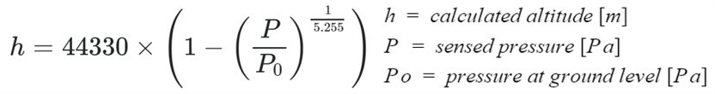

Descent Control Design

**Sample Output**

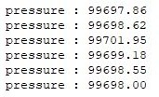

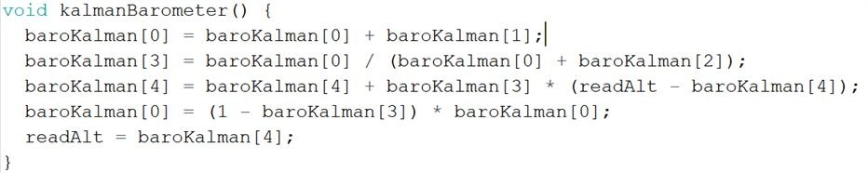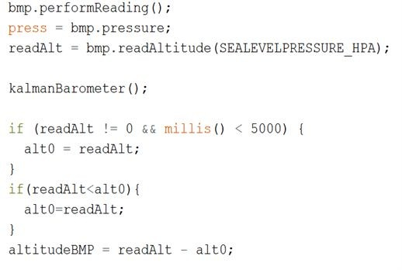

**Kalman Filter**

**Data Processing**

|  |  |  |  |  |  |  |  |  |
| --- | --- | --- | --- | --- | --- | --- | --- | --- |
| *Sensor* | | | | *Adafruit BMP 280* | | | | |
| Temperature Range (°C) | **Operating Voltage (V)** | **Weight (g) / Dimension (mm)** | **Current Consumption (uA)** | | **Resolution (Pa)** | **Accuracy (hPa)** | **Interface** | **Data Format** |
| 0 – 65 | 1.65 – 3.6 | 1.2  21.6 x 16.6 | 2,7 | | 0.016 | ±0.08 | I2C, SPI | Float  XX.XX (C) |

Payload Air Pressure Sensor Summary

(2 of 2)

Temperature data will be collected and processed with the help of Adafruit_BMP3XX library. No further processing is needed as the reading is very stable.

**Sample Output**

**Data Processing**

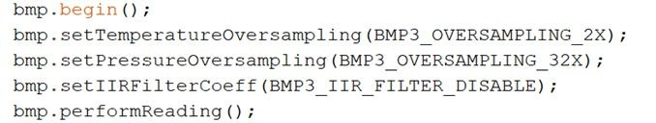

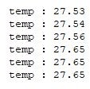

GPS Sensor Summary

|  |  |
| --- | --- |
| Sensor | Matek SAM M8Q + Compass |

|  |  |  |  |  |  |  |  |  |
| --- | --- | --- | --- | --- | --- | --- | --- | --- |
| Tracking Sensitivity (dBm) | Operating Voltage (V) | Weight (g) / Size (mm) | Current Consumption (mA) | Channel | Accuracy (m) | Interface | Update Rate (Hz) | Data Format |
| -165 | 4-6 | 7  20 x 20 x 10 | 29 | 72 | ~2.5 | UART | 18 | Float and Integer |

Longitude, latitude, and the other data will be collected and processed with the help of Tiny GPS Plus library by Mikal Hart. This sensor can lock onto GPS satellite quickly.

**Data Processing**

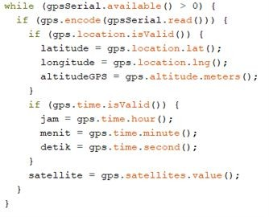

**Sample Output**

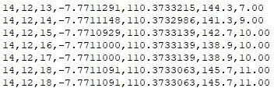

Left to right:

Hour, minute, second, latitude, longitude, altitude, satellite

**Source:** [**https://github.com/mikalhart/TinyGPSPlus/blob/master/src/TinyGPS%2B%2B.h**](https://github.com/mikalhart/TinyGPSPlus/blob/master/src/TinyGPS%2B%2B.h)

Payload Voltage Sensor Summary

|  |  |  |  |  |
| --- | --- | --- | --- | --- |
| Name | Range (V) | Error rate (%) | Interface | Data Format |
| Processor Analog Pin (Voltage Divider) | 0 - 5 | 0.03 | ADC | Float  X.XX (Volt) |

Battery voltage is measured using the ADC port trough a voltage divider, the following resistors are used in the circuit.

**R1** = 1 MΩ

**R2** = 100 kΩ

The ATSAMD Processor ADC has maximum resolution of 32-bit with 3.3 volt analog reference, but the resolution used is 16-bit resolution. So, the maximum accuracy of this on board voltage sensor is 50 uV..

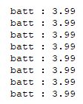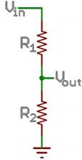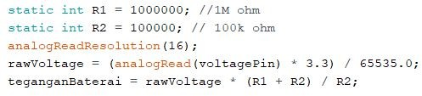

**Sample Output**

**Data Processing**

Gyroscope Sensor Selection Summary :

|  |  |  |  |  |  |  |  |  |
| --- | --- | --- | --- | --- | --- | --- | --- | --- |
| **Sensor** | **Range**  **(**°/s**)** | **Resolution**  **(bit)** | **Accuracy**  **(**°/s**)** | **Data**  **Interface** | **Operating Voltage (V)** | **Cost**  **(Rs.)** | **Dimension**  **(mm)** | **Weight**  **(gm)** |
| MPU6050 | ±250 | 16 | 1.9 | I2C/IIC | 3-5 | 120 | 4 X 4 X 0.9 | 3 |

**Reason for selecting MPU6050 :**

* Light weight, small size and Low Cost.
* Using same sensor for acceleration and orientation measurement will reduce the cost and weight of Cansat.